**Topics:**

1. **Software project management**
2. **Management activities**
3. **Project planningx**
4. **Activity organizationx**
5. **Milestones in the requirement process**
6. **Project schedulingx**
7. **Activity networks**
8. **Risk management**
9. **The Risk Management process Stages**
10. **Risk Identification**
11. **Risk Analysis @ @**
12. **Risk Planningx**
13. **Risk management strategies**
14. **Risk monitoringx**
15. **Risk indicatorsx**

* **Software project management**

1. Software project management ensures that software is delivered on time and meets the required specifications.
2. Managing a project is essential because software development must adhere to budget and timeline constraints.

* **Management activities**
* **Proposal Writing:** Create a clear plan to get approval for a project.
* **Project Planning & Scheduling:** Organize tasks, set timelines, and assign resources.
* **Project Costing:** Estimate and manage the budget for the project.
* **Project Monitoring & Reviews:** Track progress and make adjustments as needed.
* **Personnel Selection & Evaluation:** Choose the right team and assess their performance.
* **Report Writing & Presentations:** Share updates and results with stakeholders.
* **Project planningx**

1. Project planning is likely the most time-consuming part of managing a project.
2. It is an ongoing process from the initial idea until the system is delivered. Plans need to be updated regularly as new information comes in.
3. Different types of plans may be created to support the main project plan, which focuses on schedule and budget.

* **Activity organizationx**

1. Project activities should be organized to produce clear outputs that help management assess progress.
2. Milestones are the end-point of a process activity.
3. Deliverables are project results delivered to customers.
4. The waterfall process makes it easy to define progress milestones.

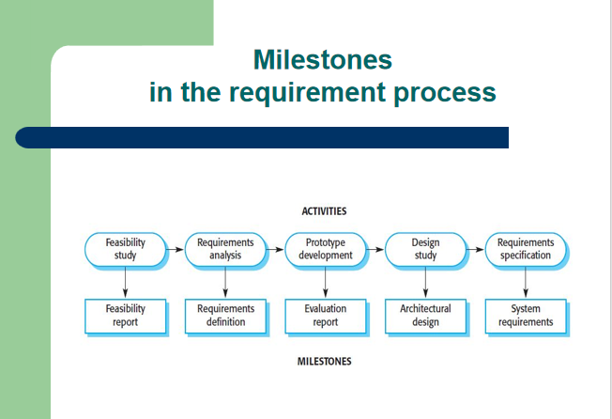

* **Project schedulingx**

1. Break the project into tasks and estimate the time and resources needed for each task.
2. Organize tasks concurrently to make optimal use of workforce.
3. Reduce task dependencies to avoid delays caused by waiting for other tasks to finish.
4. Dependent on project managers intuition and experience.

* **Activity networks**

Activity Networks are diagrams that show the flow and dependencies of tasks, including milestones, to help plan and manage the project schedule.Activity networks typically include:

Tasks/Activities: Individual tasks that need to be completed.

Dependencies: Relationships between tasks that determine the order in which they should be performed.

Milestones: Significant points or events in the project timeline.(Milestones are specific points in time that signify important achievements or stages.)

Critical Path: The longest sequence of dependent tasks that determines the minimum project duration.

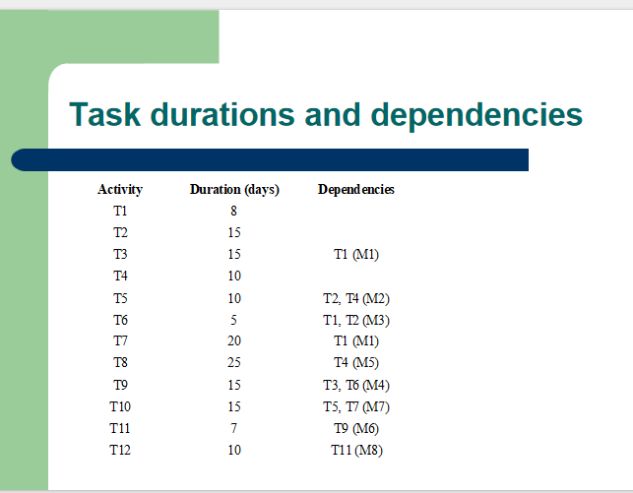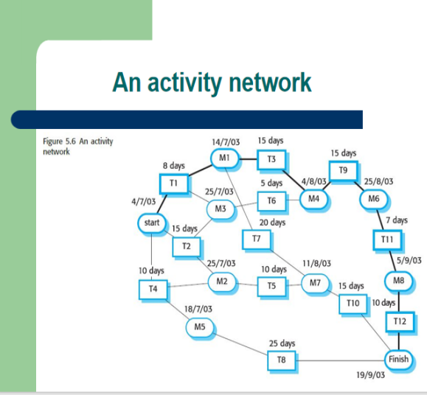

* **Risk management**

Risk management involves identifying risks and creating plans to reduce their impact on a project.

There are three main types of risks:

**Project risks:** Affect the project schedule or resources, like losing a key team member.

**Product risks (quality risks):** Affect the software's quality or performance, such as a purchased component not working as expected.

**Business risks:** Affect the organization, like a competitor launching a new product.

|  |  |  |
| --- | --- | --- |
| **Risk** | **Risk type** | **Description** |
| Staff turnover | Project | Experienced team members may leave before the project is finished. |
| Management change | Project | Organizational management may change, bringing different priorities. |
| Hardware unavailability | Project | Essential hardware might not be delivered on time. |
| Requirements change: | Project & product | There will be a larger number of changes to the requirements than anticipated. |
| Specification delays: | Project & product | Specifications of essential interfaces are not available on schedule. |
| Size underestimate | Project & product | The size of the system has been underestimated. |
| CASE tool under-performance | Product | CASE tools may not perform as expected. |
| Technology change | Business | The technology used for the system might become outdated. |
| Product competition | Business | A competitive product is marketed before the system is completed. |

* **The Risk Management process Stages**

**Risk identification:** Identify project, product, and business risks.

**Risk analysis:** Assess how likely each risk is and what its impact could be.

**Risk planning:** Create plans to avoid or reduce the impact of risks.

* **Risk monitoring:** Continuously assess risks and update mitigation plans as more information becomes available.

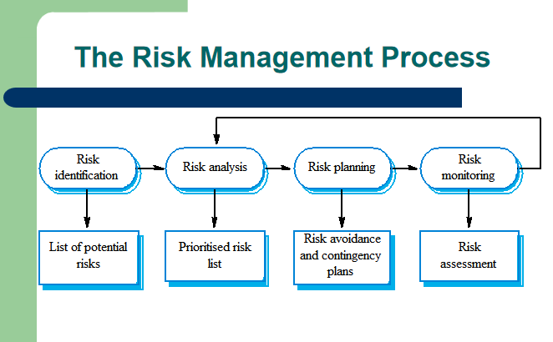

* **Risk Identification:** This is the initial step in risk management, focused on identifying potential risks to the project.

Methods: It can be done as a team activity using brainstorming or based on past experiences.

Types of Risks:

Technology Risks: Risks related to technology used in the project.

People Risks: Risks associated with the team or personnel.

Organisational Risks: Risks stemming from the organization's structure or processes.

Requirements Risks: Risks related to project requirements and specifications.

Estimation Risks: Risks arising from inaccurate project estimates.

X Don’t need this table X

|  |  |
| --- | --- |
| Risk Type | Possible risks |
| Technology | Database may not handle expected transactions; reusable software components may have defects. |
| People | Difficulty in hiring skilled staff; key staff may be unavailable; required training may not be available. |
| Organisational | Management changes; budget cuts due to financial issues. |
| Tools | Inefficient code from CASE tools; integration issues with CASE tools. |
| Requirements | Major design changes due to requirement changes; customers may not understand the impact of changes. |
| Estimation | Underestimation of development time, defect repair rate, and software size. |

* **Risk Analysis: ( Don’t Know About It )**

Assess the likelihood and impact of each risk.

Probability Levels: Very low, low, moderate, high, very high.

Impact Levels: Catastrophic, serious, tolerable, insignificant.

|  |  |  |
| --- | --- | --- |
| **Risk** | **Probability** | **Impact** |
| Budget cuts due to financial problems. | Low | Catastrophic |
| Unable to hire skilled staff. | High | Catastrophic |
| Key staff ill at critical times. | Moderate | Serious |
| Defects in reusable software components. | Moderate | Serious |
| Major design changes due to requirement shifts. | Moderate | Serious |
| Management changes due to restructuring. | High | Serious |
| Database can't handle expected transactions. | Moderate | Serious |
| Development time underestimated. | High | Serious |
| CASE tools can't be integrated. | High | Tolerable |

* **Risk Planning:x**

Consider each risk and develop a strategy to manage that risk.

These strategies fall into three categories:

* **Avoidance Strategies:** Reduce the chance of the risk occurring (e.g., handling defective components).
* **Minimisation Strategies:** Reduce the impact of the risk (e.g., managing staff illness).
* **Contingency Plans:** Have plans ready if the risk occurs (e.g., dealing with financial problems).
* **Risk management strategies**

|  |  |
| --- | --- |
| **Risk** | **Strategy** |
| Organisational Financial Problems: | Show management the project's importance. |
| Recruitment Problems: | Warn the customer, consider buying components. |
| Staff Illness: | Reorganize team, share tasks. |
| Defective Components: | Replace with reliable components. |
| Requirements Changes: | Understand impact, keep design simple. |
| Organisational Restructuring: | Show management the project's importance. |
| Database Performance: | Buy a better database. |
| Underestimated Development Time: | Buy components or use a program generator. |

* **Risk Monitoring:** x

Regularly assess identified risks to see if they are becoming more or less likely.

Factors to Observe: Monitor specific factors that indicate changes in risk probability and impact, depending on the type of risk.

* **Risk indicatorsx**

|  |  |
| --- | --- |
| **Risk Type** | **Potential Indicators** |
| Technology | Late hardware/software delivery, frequent tech issues |
| People | Low morale, poor team relationships, job availability |
| Organisational | Gossip, lack of senior management action |
| Tools | Team reluctance to use tools, complaints about CASE tools, demands for better workstations |
| Requirements | Many change requests, customer complaints |
| Estimation | Missed schedules, unresolved defects |